I’ve never discussed with anyone in regard to the project. I have not helped anybody or gotten helped by anybody while working on this project.

Name: __________________________, Honor Signature: _______________________________

Using Matlab, make a program code that can be used by any mechanical engineers who understand linkage mechanisms and Matlab program. With your Matlab program and a brief communicable manual, mechanical engineers must be able to obtain the followings:

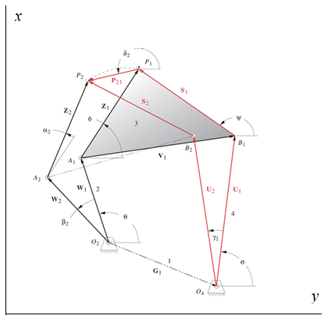

Given:

1. Rotation angle of coupler (2=5o).
2. Two positions of P: P1=(9.0”, 17.5”) and P2=(4.0”, 16.0”).
3. While P is moving from P1 to P2, the entire mechanism should be bounded by an 18” X 18” area: The area’s corner points are at (0,0), (18,0), (18, 18) and (0, 18).

Your program iterations:

1. Use the discussed Strategy #1 to determine w, , 2, z and 
2. Use the discussed Strategy #1 to determine , 2, , u and s

Find:

1. The lengths of L1 (= G1), L2 (= w), L3 (= V1), L4 (= u), z and s.
2. Locations of O2, O4, A1, A2, B1 and B2.
3. (a) and (b) must satisfy the given area limit.
4. For your mechanism demo, select the mechanism with [ L2 (w) + L3 (V1) + L4 (u) ] minimum among your many mechanisms. Using SAM, show the mechanism works and moves within 18” X 18” while P’s moving from P1 to P2.

Additional Requirements:

* Prepare 5 min demo presentation including a SAM animation.
* Your Matlab program must be able to handle any problem with different sets of initial input values of P1, P2 and a2.
* You may assume that P1 and P2 are two positions of P (Not necessarily toggle positions). It means that you do not need to make link #2 or link #4 as a crank.
* Your designed mechanism should be bounded by the specified rectangular area with the dimension (18” X 18”). The position of the rectangle is specified/given. You must include a process in your Matlab program to check if your mechanism is always within the given space limit – while P’s moving from P1 to P2.
* Your assumed values of , 2,  , 2,  can be used as iteration (such as “for-end”) parameters with a step value 1o.
* You will find multiple sets of solutions. Make a communicable table for selected 10 sets of the designed lengths of L1 (=G1), L2 (=w), L3 (=V1), L4 (=u), z and s, and positions of O2, O4, A1, A2, B1 and B2.
* Drop your Matlab file (One file) and a brief manual (Words or pdf) describing how to use your Matlab program into the specified drop box on D2L.

Grading:

|  |  |
| --- | --- |
| Working Matlab program | 50% |
| User’s manual | 10% |
| Table of 10 sets solutions of the lengths of L1, L2, L3, L4, z and s, and the positions of O2, O4, A1, A2, B1 and B2 | 10% |
| Screen shots of the mechanism @ P = P1 and @P = P2 in SAM | 10% |
| 5 min Presentation including SAM motion animation | 20% |

**(For Undergraduate students)** Form your own team: Please form your own team of two students, and email your team member names to the instructor by mid-night Tuesday 10/13/2020. For the students who do not make their teams by Tuesday, Dr. Park will make teams in alphabetical order.

**(Graduate students only)**

1. A graduate student who’s taking ME 518-01 or ME 518-02 must complete the project individually.

2. Pick one mechanism from the ten sets of your solutions, and add a driver dyad (two links including a crank) to make P1 and P2 as two toggle positions of P. All the positions of joints and links including the driver dyad must be within the specified rectangular area. You must effectively prove that the two points are the toggle positions.